From Sales Data
SUM FUNCTIONS

What is the total revenue from Office Supplies?
- =SUMIF('Sales Data'!H4:H105,"Office Supplies",'Sales Data'!N4:N105)

What is the total revenue from Melbourne?
- =SUMIF('Sales Data'!H4:H105,"Electronics",'Sales Data'!N4:N105)
Category First -> Then Value
What is the total revenue from VIC for Furniture?
- =SUMIFS('Sales Data'!N4:N105,"Furniture",'Sales Data'!H4:H105,"VIC",'Sales Data'!F4:F105)
Value -> Column -> Condition ->Column -> Condition etc.

COUNT FUNCTIONS
How many Furniture orders are in VIC?
- =COUNTIF('Sales Data'!O4:O105,"Delivered")
How many Furniture orders are in VIC?
- =COUNTIFS('Sales Data'!H4:H105,"Furniture",'Sales Data'!F4:F105,"VIC")
How many orders have a discount > 0?
- =COUNTA('Sales Data'!M4:M105)

AVERAGE MIN MAX
Average order value for Furniture?
- =AVERAGEIF('Sales Data'!H4:H105,"Furniture", 'Sales Data'!N4:N105)
What is the top 3rd highest order?
- =COUNTIFS('Sales Data'!H4:H105,"Furniture",'Sales Data'!F4:F105,"VIC")
Average for Bob Smith's delivered orders?
- =AVERAGEIFS('Sales Data'!N4:N105, 'Sales Data'!O4:O105,"Delivered",'Sales Data'!P4:P105,"Bob Smith")

IF Functions
If quantity > 3, label "Bulk" else "Single"
- =IF('Sales Data'!J3>3, "Bulk","Single")
Create a 3-tier label: qty>=4 "Large", qty>=2 "Medium", else "Small"
- =IFS('Sales Data'!J3 >= 4, "Large", 'Sales Data'!J3 >= 2, "Medium",'Sales Data'!J3 < 2,"Small")
Flag if Returned AND amount > $500
- =IF(AND('Sales Data'!O4:O105="Returned",'Sales Data'!N4:N104>500),"Yes","No")

VLOOKUP and XLOOKUP
Look up the price of "Webcam HD" using VLOOKUP (String, Table, Column, FALSE()).
- = VLOOKUP(“Webcam HD”,A12:E26,3,FALSE())
Look up the stock level of "Standing Desk" using XLOOKUP
- = XLOOKUP(C30,A12:A26,D12:D26,"Not Found")
In C30 cell, Enter Standing Desk Manually
Look up a product that doesn't exist — see the difference!
- = XLOOKUP(D30,A12:A26,D12:D26,"Not Found")
In D30 cell, Enter Nintendo Switch for Example to see the difference.

TEXT Functions
Extract the order number (last 4 digits) from "ORD-1088
- = RIGHT('Sales Data'!A7,4)
Combine city and state: "Sydney" + "NSW" → "Sydney, NSW" (My Example)
- =CONCAT('Sales Data'!E14, " ",'Sales Data'!F14)
Clean this: " MESSY DATA " → "Messy Data" (Too Simple)
- =TRIM(" MESSY DATA ")

Pivot Tables
📝 STEP-BY-STEP INSTRUCTIONS
STEP 1: Go to the "📊 Sales Data" sheet → Click any cell in the data (e.g., A1)
STEP 2: Insert → PivotTable → Select "New Worksheet" → Click OK
STEP 3: The PivotTable Field List will appear on the right side
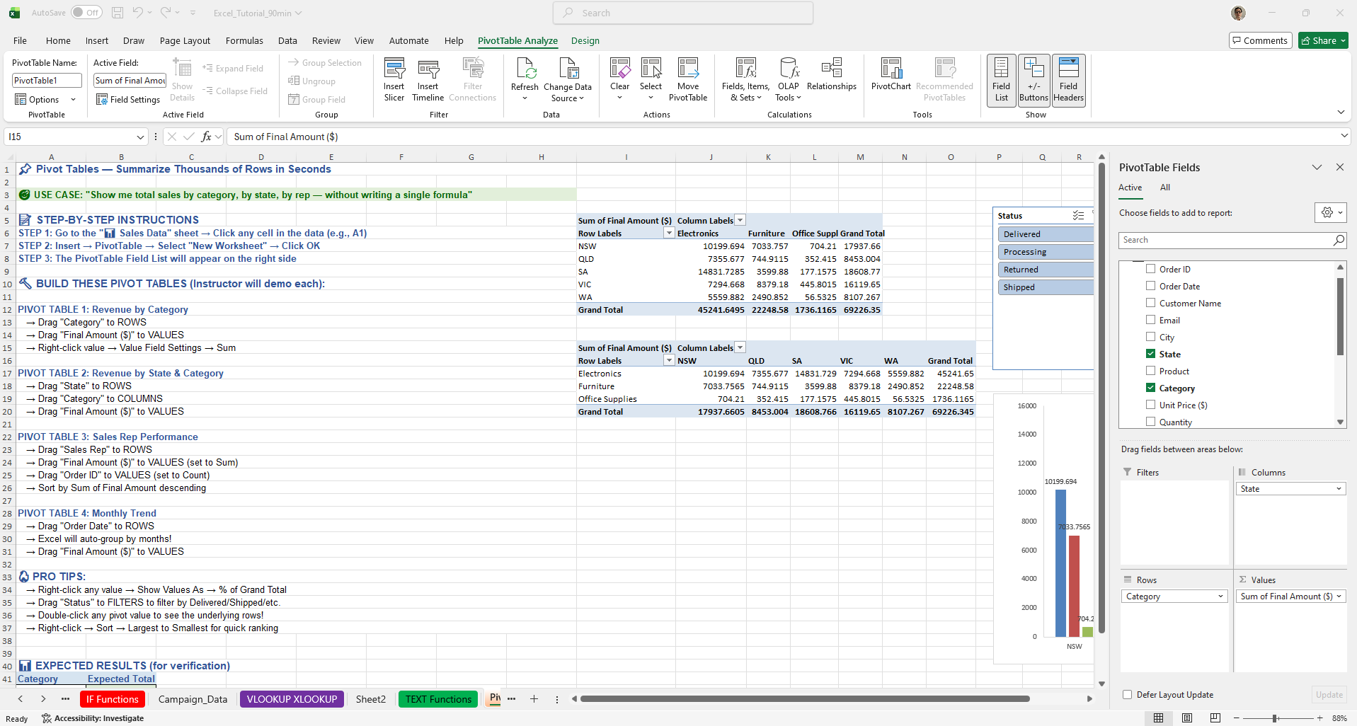
Now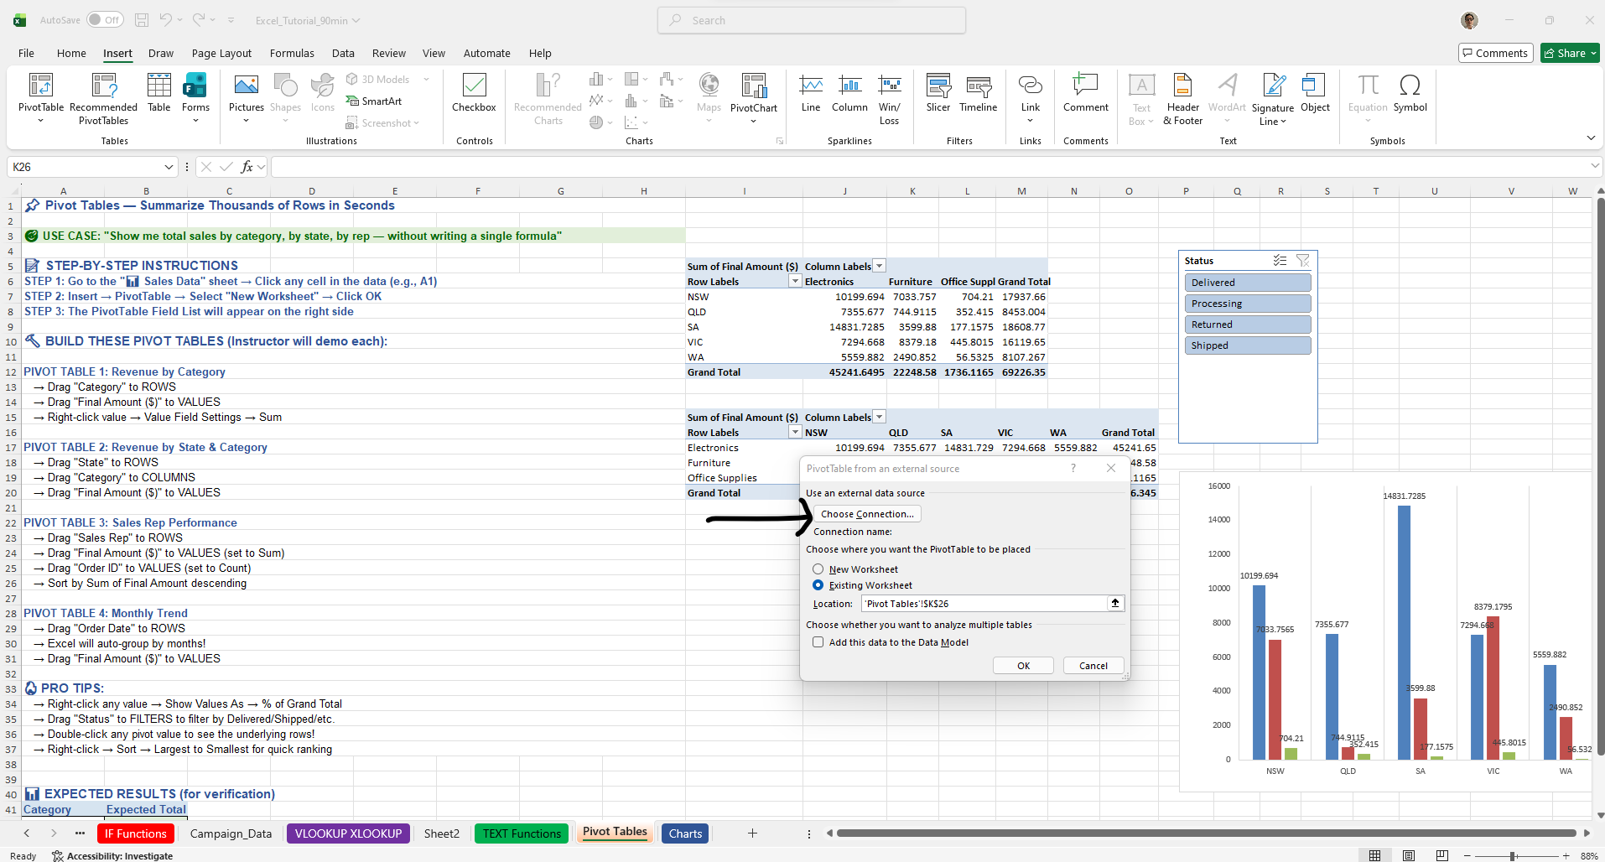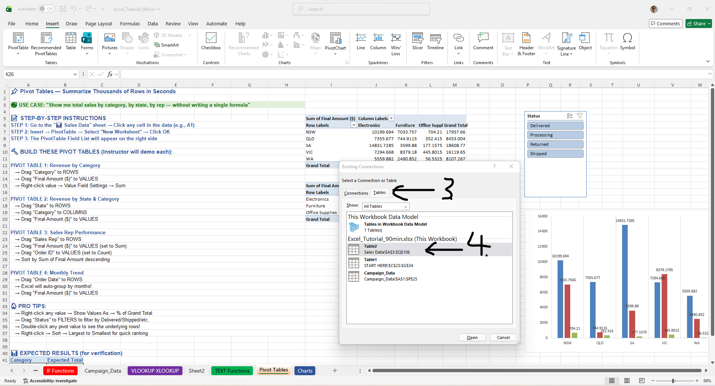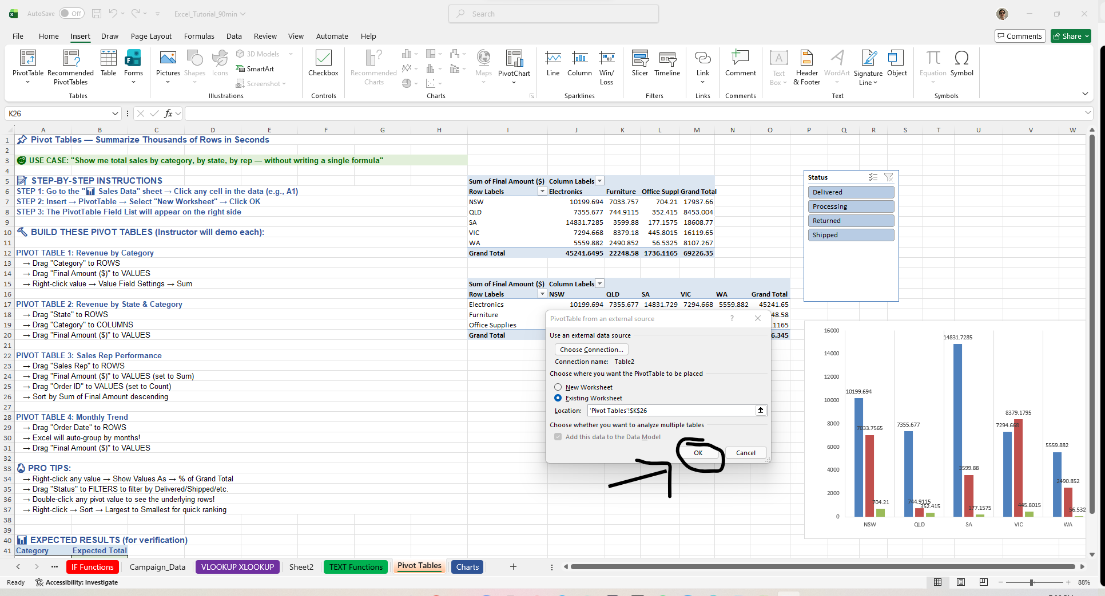

PIVOT TABLE 1: Revenue by Category
→ Drag "Category" to ROWS
→ Drag "Final Amount ($)" to VALUES
→ Right-click value → Value Field Settings → Sum

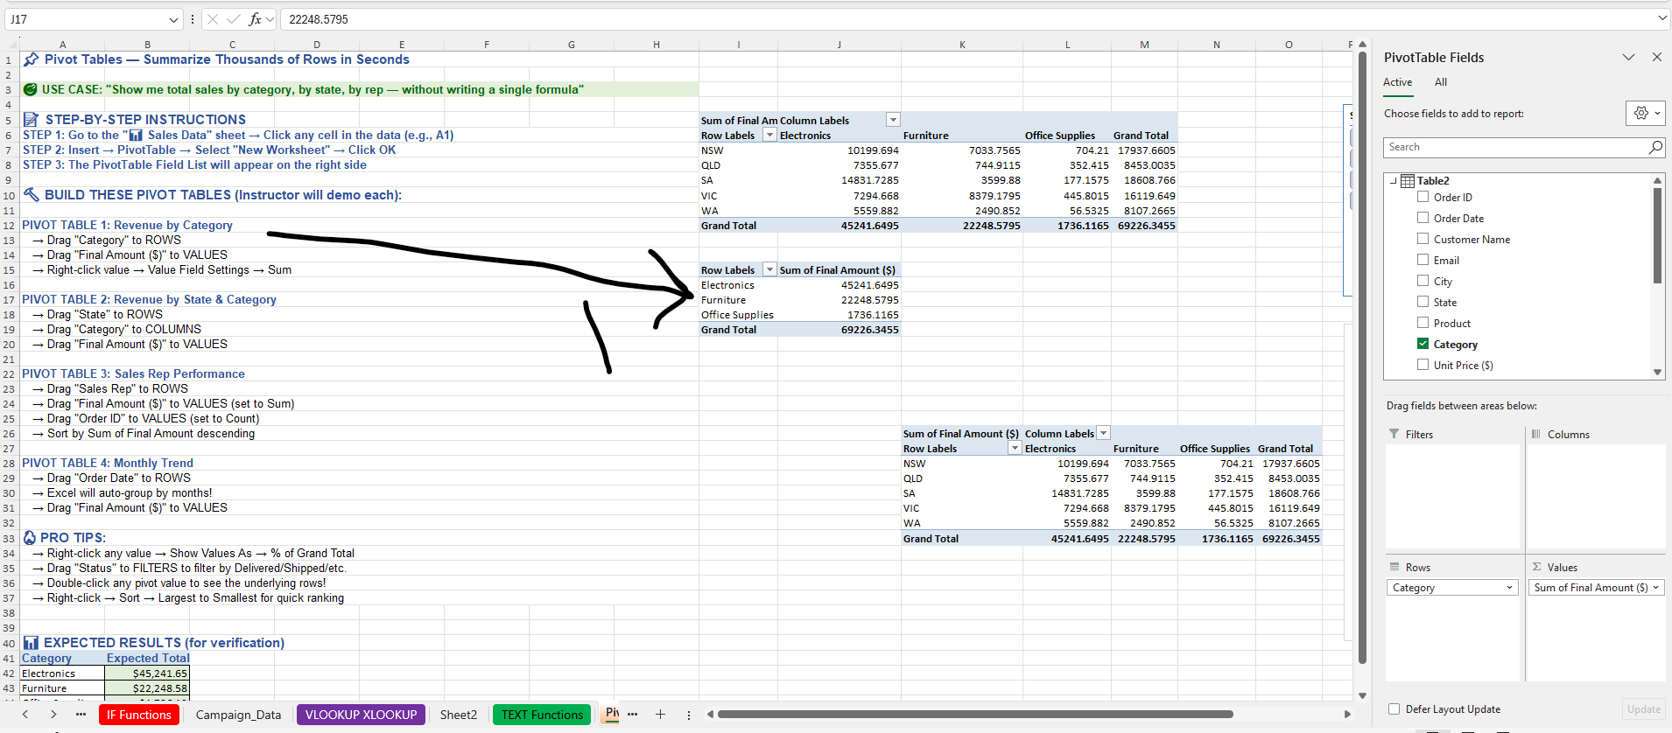

PIVOT TABLE 2: Revenue by State & Category
→ Drag "State" to ROWS
→ Drag "Category" to COLUMNS
→ Drag "Final Amount ($)" to VALUES
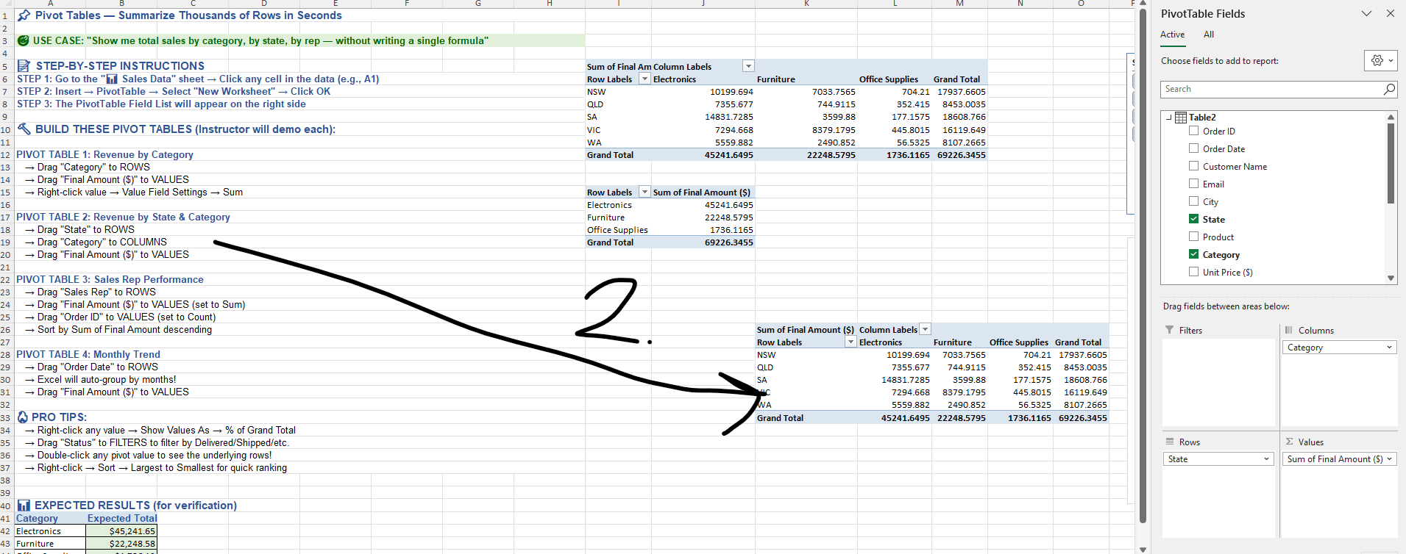

PIVOT TABLE 3: Sales Rep Performance
→ Drag "Sales Rep" to ROWS
→ Drag "Final Amount ($)" to VALUES (set to Sum)
→ Drag "Order ID" to VALUES (set to Count)
→ Sort by Sum of Final Amount descending
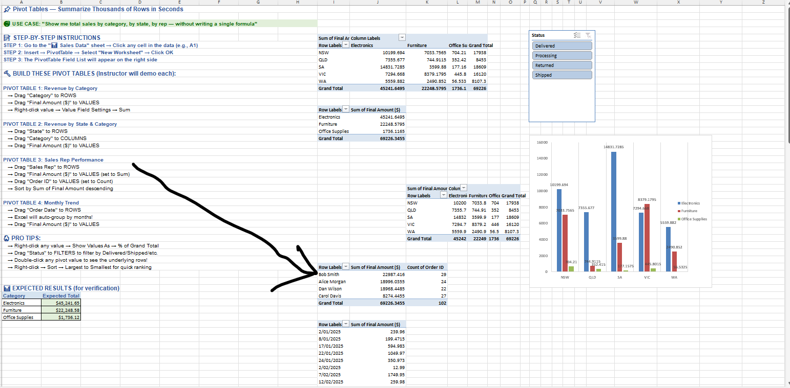

PIVOT TABLE 4: Monthly Trend
→ Drag "Order Date" to ROWS
→ Excel will auto-group by months!
→ Drag "Final Amount ($)" to VALUES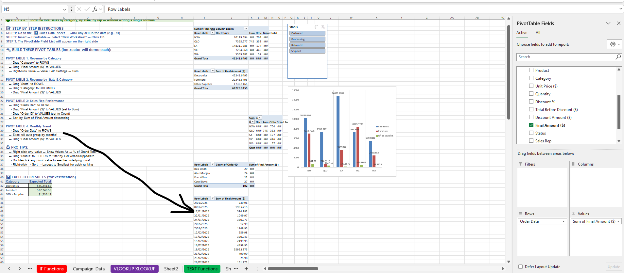

WHEN IN DOUBT:
https://support.microsoft.com/en-au/office/create-a-pivottable-to-analyze-worksheet-data-a9a84538-bfe9-40a9-a8e9-f99134456576

Charts
📊 CHART 1: Revenue by Category (Column Chart) 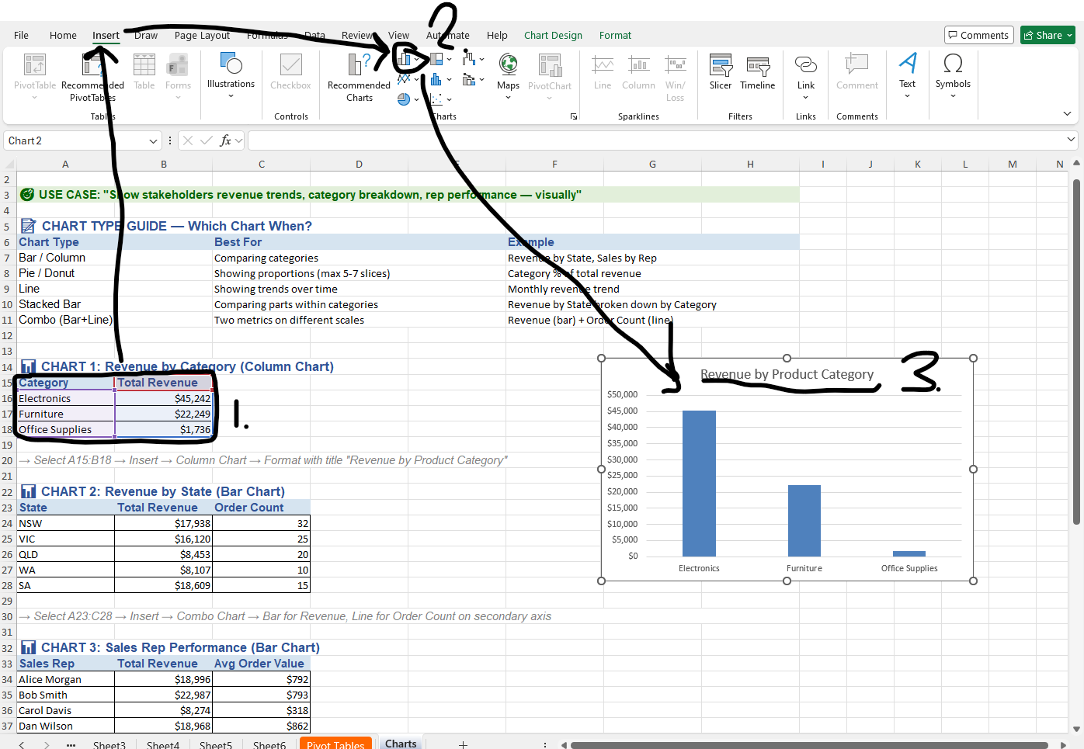
📊 CHART 2: Revenue by State (Bar Chart) 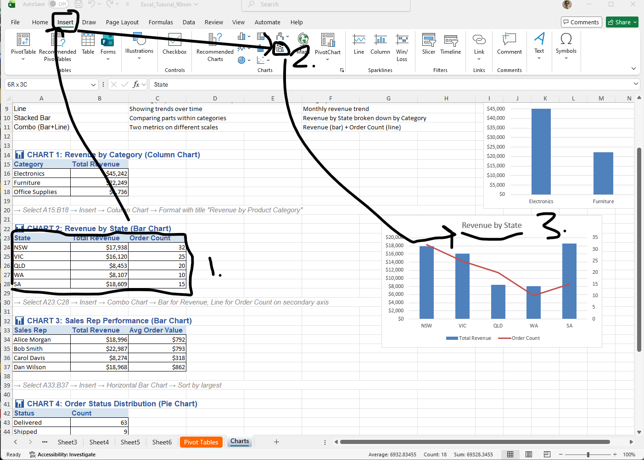
📊 CHART 3: Sales Rep Performance (Bar Chart)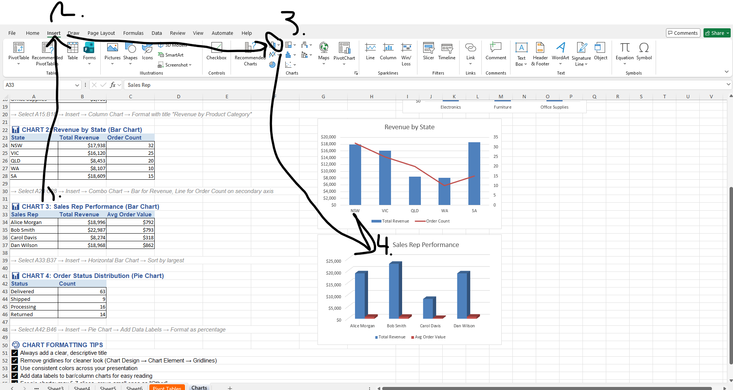
On 3. Select 3-D Column Chart

NOTE: 1️⃣ Sort the source data (this is the key)
Charts follow the order of the data range.
- Select A33:C37 (include headers if you have them)
- Go to Data → Sort
- Set:
  - Sort by: Total Revenue
  - Sort On: Values
  - Order: Largest to Smallest
- Click OK
✅ This keeps Sales Rep, Total Revenue, and Avg Order Value aligned.
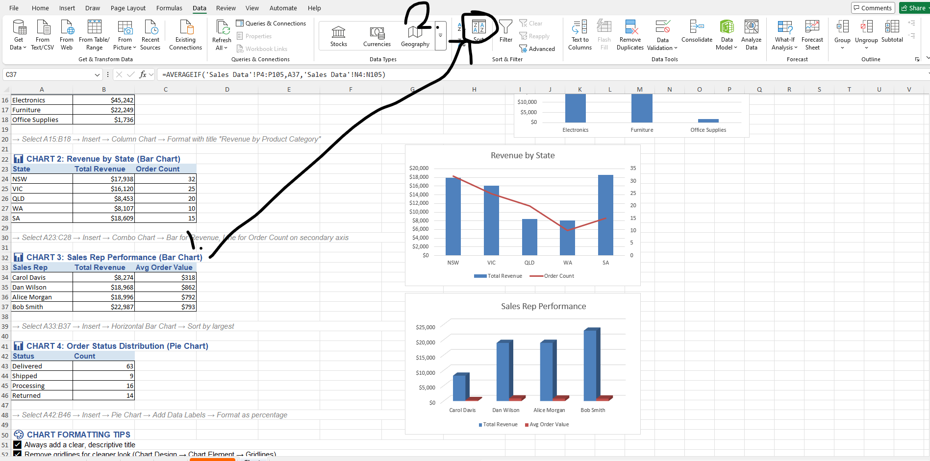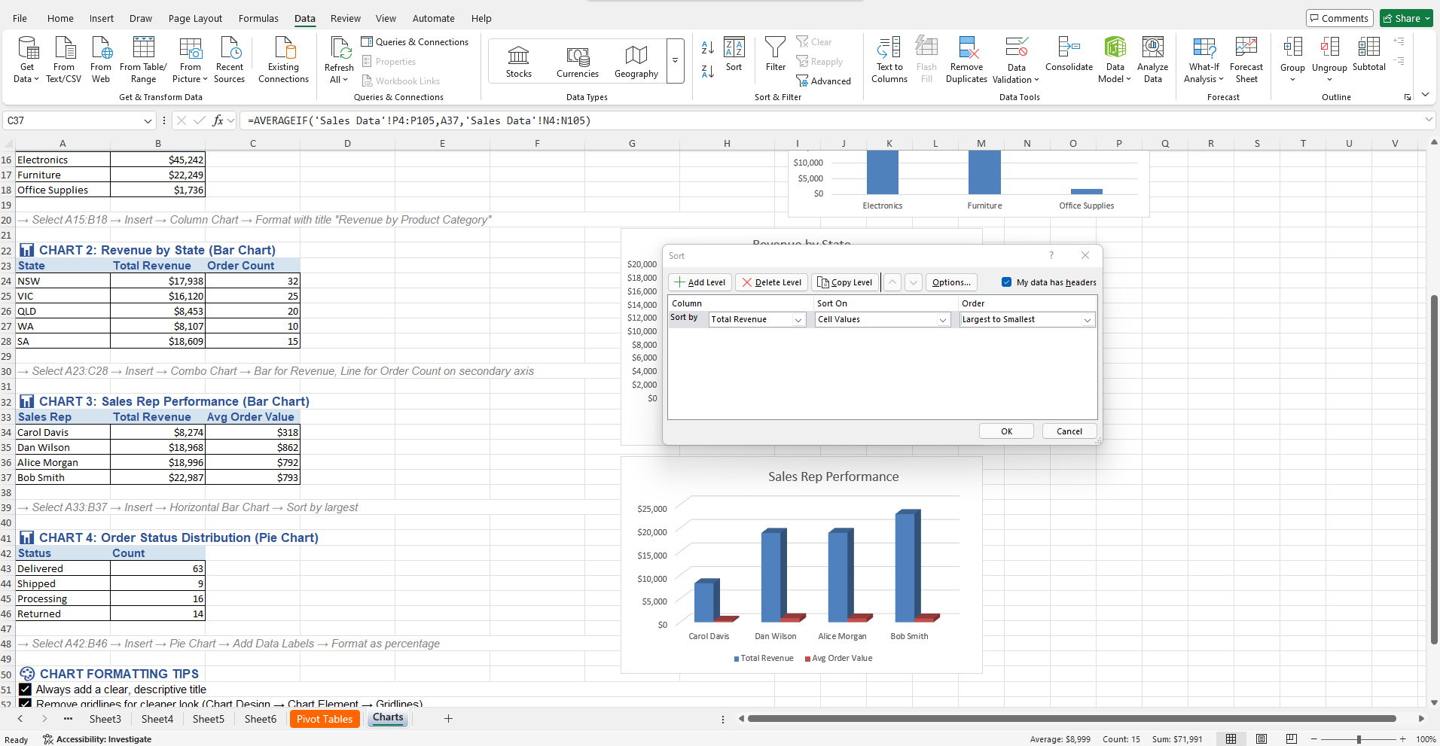

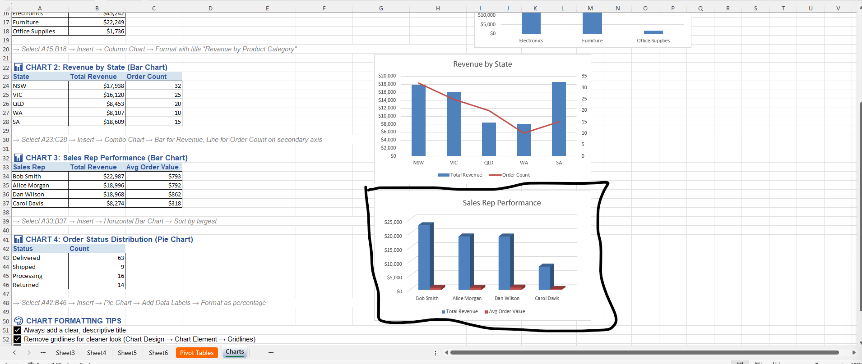

📊 CHART 4: Order Status Distribution (Pie Chart)
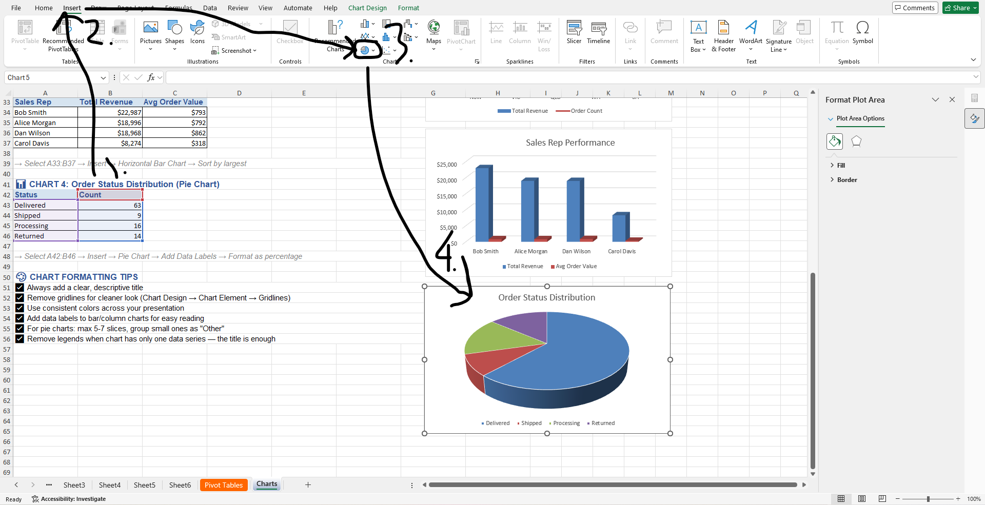
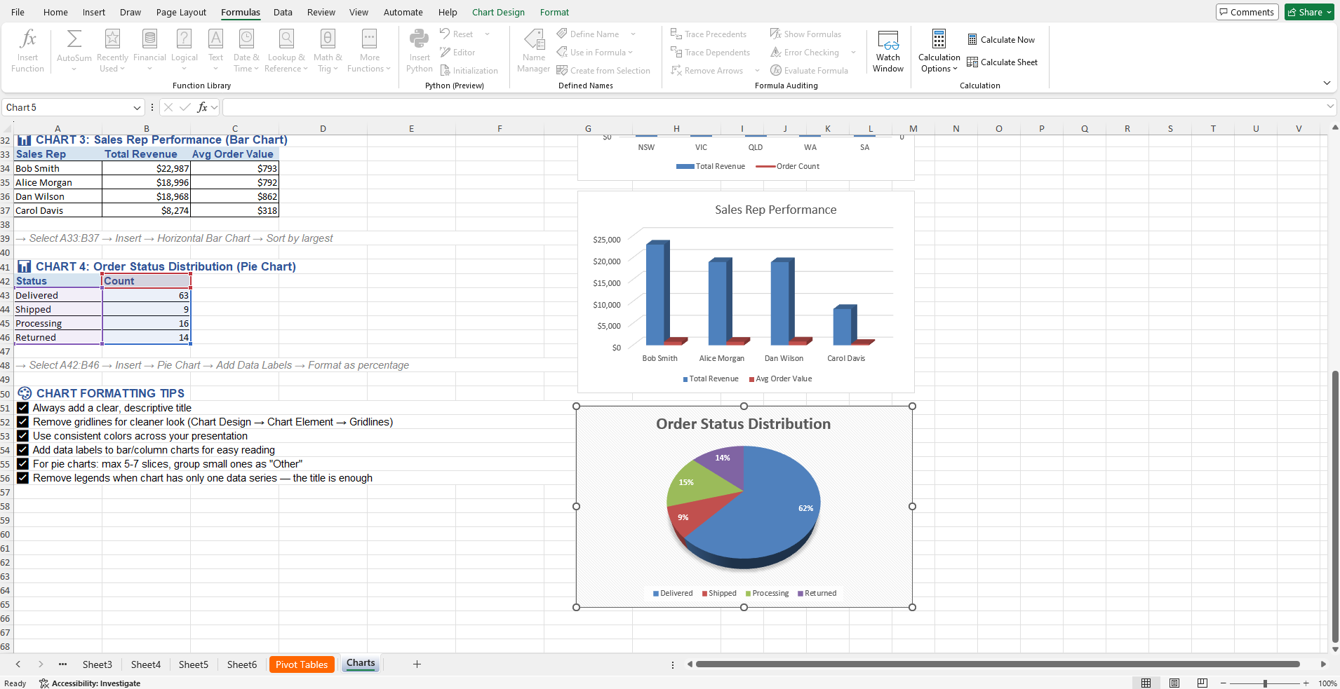
Click on the paint icon on the visual and select the pie-chart that has the percentages for each sector.

